Cell info

Supervisor. | Miss Esha Shahid
Batch. | 2506F2
Group. | B
Serial No. | Enrollment Number | Student Name
1. | Student 1669168 | Arbash Murataza
2. | Student 1669153 | Abeera Malik
3. | Student 1672376 | Aafia Naz

ACKNOWLEDGEMENT
I would like to express my sincere gratitude to my teachers and mentors at Aptech Global Learning Solutions for their continuous guidance, encouragement, and support throughout the development of my project “Cell Info”. Their valuable feedback and knowledge helped me understand web development concepts and apply them effectively.
I am also thankful to my classmates
- Arbash Murtaza
- Abeera malik
- Aafia Naz
Your efforts, creativity, and hard work have been instrumental in bringing this vision to life. We truly appreciate your collaboration and enthusiasm throughout this journey.
SYNOPSIS
Cell Info is an informative website designed to provide complete details about different mobile phones, including their features, specifications, and prices. The website helps users easily compare various phone models and brands. It is developed using HTML, CSS, JavaScript, PHP, and MySQL, ensuring an interactive, responsive, and user-friendly design. The project aims to create a simple and efficient platform for users to make better phone choices through an organized and visually appealing interface.
PROBLEM DEFINITION
. In today’s fast-growing mobile market, users often face difficulty finding accurate and detailed information about the latest phones. With so many brands and models available, comparing features such as battery life, camera quality, performance, and price becomes time-consuming and confusing. Many existing websites are either overloaded with ads or lack proper comparison features, making it hard for users to make informed decisions.
To solve this problem, the Cell Info website is designed to provide a simple, organized, and user-friendly platform where users can view complete details and compare different mobile phones easily. The project focuses on delivering reliable information, smooth navigation, and a clean layout for a better browsing experience.

CUSTOMER REQUIREMENT
SPECIFICATION (CRS)
The Web site is to be created based on the following requirements.
1) The Home Page should be created with proper sections, graphics and logo.
2) A Menu should be created which would categorize all the information about
the features provided in the Site For e.g. a Menu for Various Cell phones, a
Menu for Features of Cell phones etc etc something like that.
3) The information should be categorized according to the Brand names of
Mobiles like if a User wants to see only Nokia Phones then he click on Some
Nokia Link/button etc and he will see only That Brand phones and so on.
4) A Brief summary of features of Individual phones should be displayed on the
Web Page along with the Cell phone but detailed Features should be stored in
Individual Word documents which can be downloaded or viewed by the User
who wishes to see the same.
5) A Comparison Web Page should also be there where there is Phone
comparisons done with various models of same brand or various models of
various brands.
- The Comparison information should be provided in Tabular format
comparing the features of different phones. This information would be for 5 Phones of similar brands and 2 phones
of different brands for 1 month and then it will change so for the time
being the Page should handle the above requirement.

6) The Colour Schemes should be soothing, more of Pastel Colours can be
chosen for the same.
7) When a particular brand phones are being displayed the background image of
the Web page should show the Logo of that brand for e.g. if Nokia Phones are
being displayed then that page should have the Logo of NOKIA as the
background image and the same in case of other Brands.
8) There should be a “Contact Us” page which will have the Address of the
Company which is as follows and the mail address which when clicked will
invoke the local mail client from where they can send an email.
Address of the Company: A-65, ACME Co., Street no 12, New York
Phone Numbers: +001-28272300, 2466, 2469
Email Address: webmaster@cellinfo.com
9) The information on the mobile phones and all can be picked up from the Sites
of Nokia, Samsung etc.
10) To avoid creation of html pages you can make use of layers, flash buttons and
other components of Dreamweaver for creation of pages.
11) The appearance and organization of the site will carry more chances of your
selection for getting the contract so both the factors are important to be
considered.

SCOPE OF THE WORK (IN BRIEF)
We believe that Cell Info will serve as a trusted and user-friendly platform for people who want accurate and quick information about mobile phones. The website aims to simplify the process of comparing phones, understanding their features, and making smart buying decisions. Through an attractive design, smooth performance, and reliable data, Cell Info will help users stay informed and confident in choosing the right phone for their needs
Screenshots
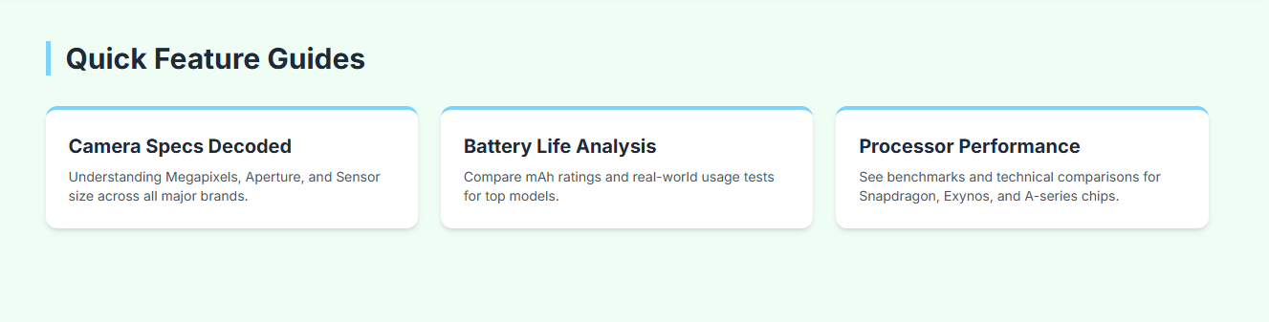
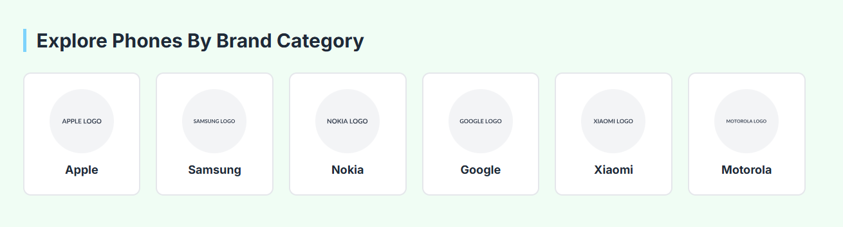
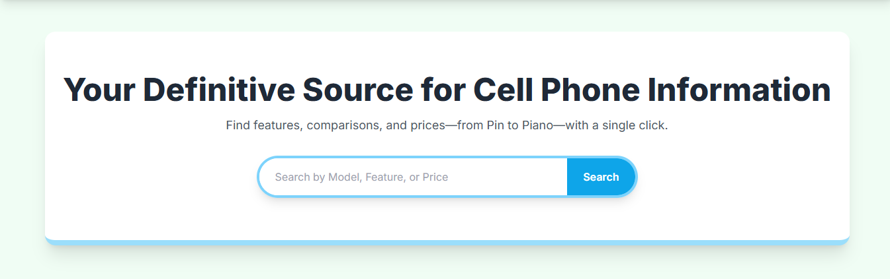
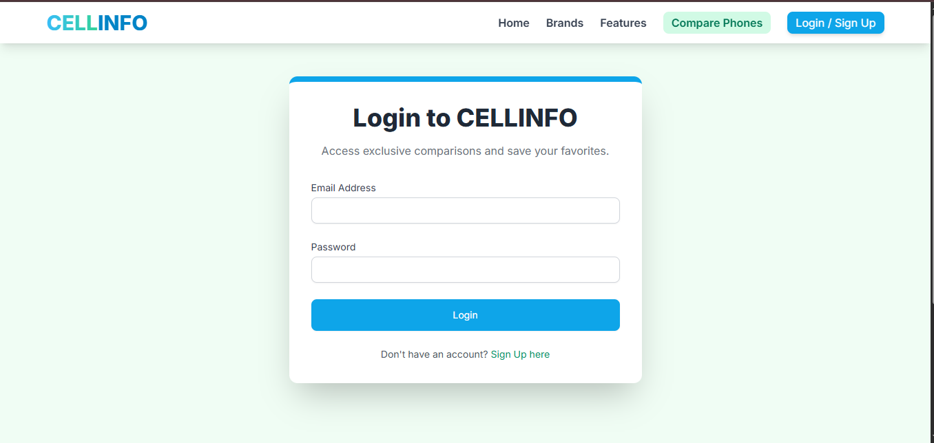
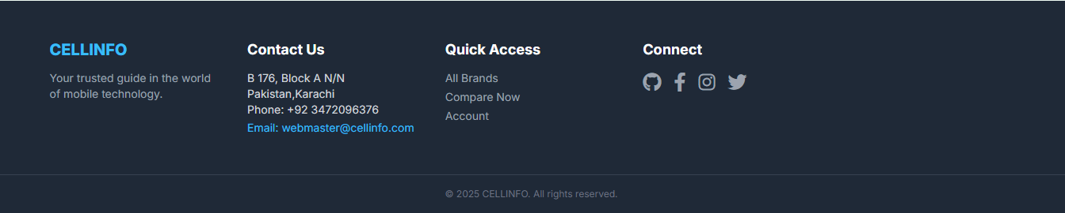
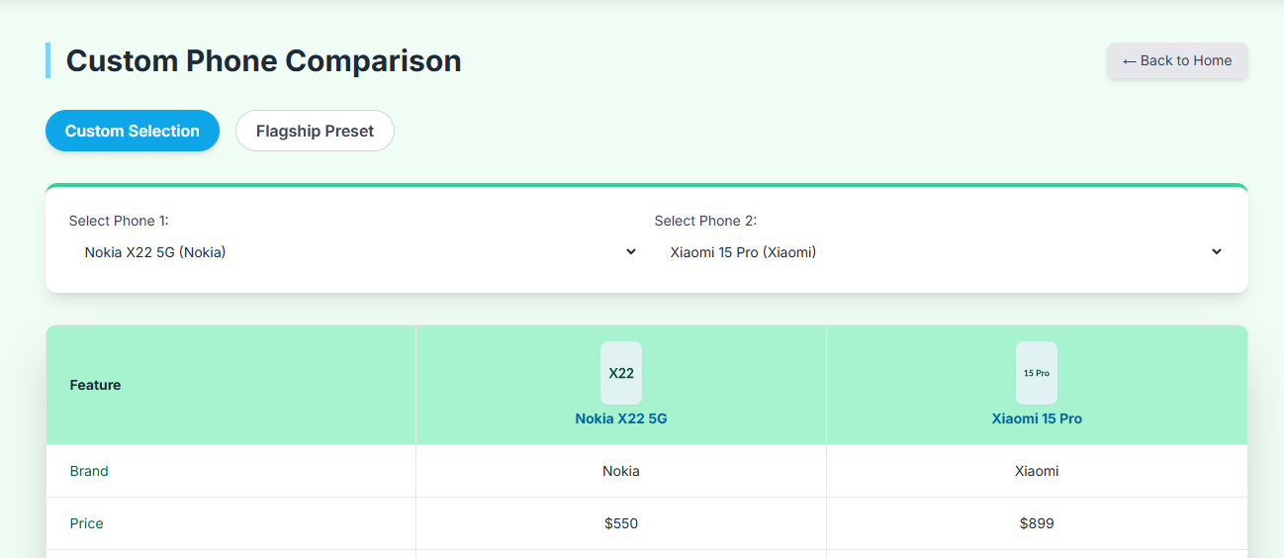

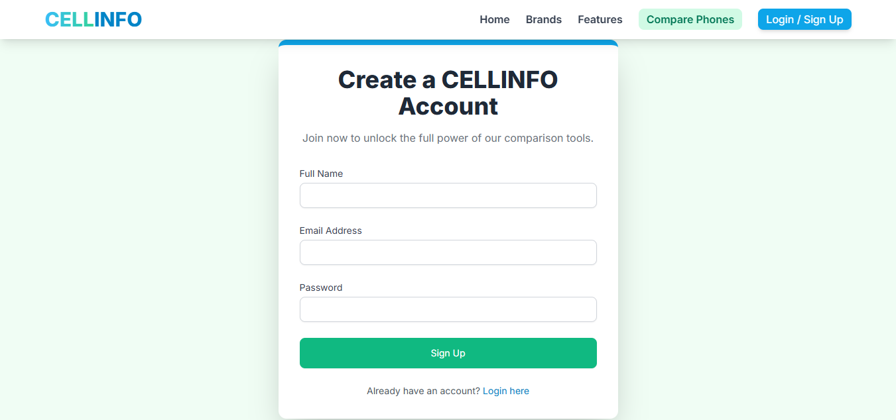
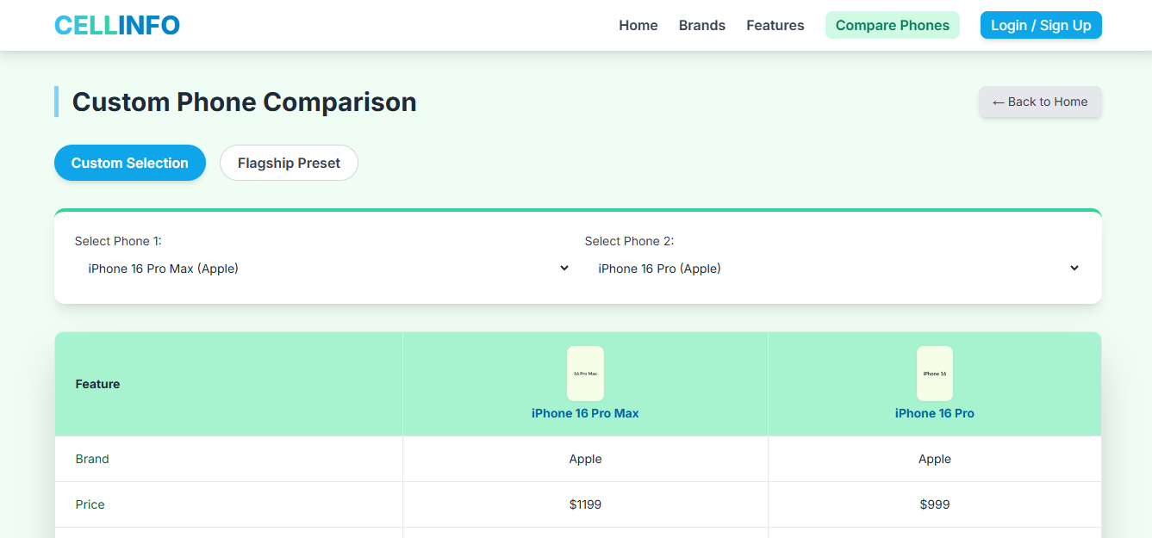

CONTENT

